COMPUTER VISION
ASSESSMENT TOOL 3
NAME: Allu Thanmai
REG .NO : 192412616
SLOT B

- A real-world scene is captured under low-light conditions. Write a Python program to enhance the low-light image.

ANSWER :
A camera model describes how a three-dimensional (3D) scene is projected onto a two-dimensional (2D) image plane. The most commonly used model in computer vision is the Pinhole Camera Model.
Light rays from an object pass through a small opening called the pinhole.
These rays are projected onto the image plane.
The size of the image depends on the focal length of the camera and the distance of the object from the camera.
If the object moves farther from the camera, the image appears smaller.
If the focal length increases, the projected image becomes larger.

CODE:

import cv2
import matplotlib.pyplot as plt
from google.colab import files

print("Upload an image")
uploaded = files.upload()

filename = list(uploaded.keys())[0]
image = cv2.imread(filename)

image = cv2.cvtColor(image, cv2.COLOR_BGR2RGB)

h, w = image.shape[:2]

focal_length = 800
object_distance = 1600

scale = focal_length / object_distance

new_width = int(w * scale)
new_height = int(h * scale)

formed_image = cv2.resize(image, (new_width, new_height))

plt.figure(figsize=(12,6))

plt.subplot(1,2,1)
plt.imshow(image)
plt.title("Original Object")
plt.axis("off")

plt.subplot(1,2,2)
plt.imshow(formed_image)
plt.title("Image Formed by Camera Model")
plt.axis("off")

plt.show()

print("===================================")
print("Camera Model Demonstration Complete")
print("Original Image Size :", w, "x", h)
print("Projected Image Size:", new_width, "x", new_height)
print("Scale Factor :", round(scale,2))
print("===================================")

OUTPUT:

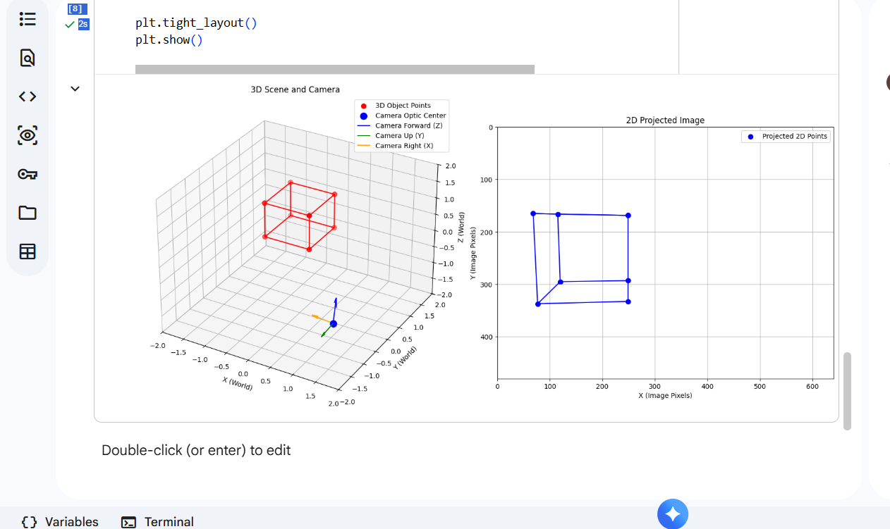

- A self-driving car uses visual input. Write a Python program for lane detection.

Lane detection is a Computer Vision technique used in self-driving cars to identify road lane markings from camera images. The captured image is converted into grayscale and filtered to reduce noise. Canny Edge Detection is applied to detect the edges of the lane markings. The Hough Line Transform is then used to detect straight lane lines. The detected lanes are highlighted on the original image to indicate the driving path. This helps autonomous vehicles maintain lane discipline and improve road safety.

Code:

import cv2
import numpy as np
import matplotlib.pyplot as plt

def create_synthetic_lane_image():
img = np.zeros((480, 640, 3), dtype=np.uint8)

road_color = (100, 100, 100) # Dark gray
pts = np.array([[0, 480], [640, 480], [400, 280], [240, 280]], np.int32)
… return img

image = create_synthetic_lane_image()

original_image = np.copy(image)
gray = cv2.cvtColor(image, cv2.COLOR_RGB2GRAY)
blur = cv2.GaussianBlur(gray, (5, 5), 0)
canny = cv2.Canny(blur, 50, 150)
…
lines = cv2.HoughLinesP(cropped_canny, 2, np.pi/180, 100, np.array([]), minLineLength=40, maxLineGap=5)
ef make_coordinates(image, line_parameters):
if line_parameters is None or len(line_parameters) < 2:
return None
slope, intercept = line_parameters
y1 = image.shape[0]
y2 = int(y1 * (3/5))
… if lines is None:
return None
for line in lines:
x1, y1, x2, y2 = line.reshape(4)

if x2 - x1 == 0:
continue
parameters = np.polyfit((x1, x2), (y1, y2), 1)
slope = parameters[0]
intercept = parameters[1]
if abs(slope) < 0.1 or abs(slope) > 10:
continue

if slope < 0:
left_fit.append((slope, intercept))
else:
right_fit.append((slope, intercept))

left_fit_average = np.average(left_fit, axis=0) if left_fit else None
… line_image = np.zeros_like(img)
if lines is not None:

if isinstance(lines, tuple):
lines_to_draw = [line for line in lines if line is not None]
elif isinstance(lines, np.ndarray):
lines_to_draw = [lines]
else:
lines_to_draw = []

…
plt.show()

OUTPUT:

